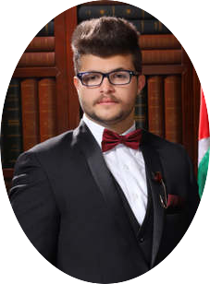

***Courses***

* ***Bachelor degree******in MECHANICAL ENGINEER***
* ***Faculty of Engineering, Balqa Applied University “polytechnic”***
* ***Average:* 3.44**
* ***Grade:******Very GOOD.***

***Education Reference***

***Basic Information***

***n***

**Mohammad Salah**

Mechanical Engineer

**MM**

***HVAC* Course**, Includes:

* Chiller
* VRF
* Package
* Split
* Work in HAB

From **011 l 2018** to  **02 l 2019 “60 hours”**

**----**

**Good general information about heavy equipment , trucks.**

* **Nationality:**  Jordanian
* **Address:** Amman
* **Mobile:** 0799119686
* **Email :** [mo7ammad.7am96@gmail.com](mailto:mo7ammad.7am96@gmail.com)

***Online Courses***

***PV System Course***, Includes:

* PV system calculation
* Methods of installation
* ***Work in PVsyst 6.7.8***

***Total: “40 hours”***

***skills***

* **Good Microsoft Software skills.**
* **Good AutoCAD Skills.**
* ***Validؤdriving license.***

***Language***

* ***Arabic : 100 %***
* ***English : 65 %***